3.STRING MANIPULATION AND POSTFIX EXPRESSION EVALUATION
AIM:
To write and implement C++ programs to perform string manipulation operations such as reversing a string and reversing each word in a sentence, and to evaluate a postfix expression using a stack.

3.1.C++ Program to Reverse a String

ALGORITHM:
Step 1: Start the program.
Step 2: Declare a string variable to store the input string.
Step 3: Read the string from the user.
Step 4: Find the length of the string.
Step 5: Traverse the string from the beginning to the middle.
Step 6: Swap each character with the corresponding character from the end of the string.
Step 7: Display the reversed string.
Step 8: Stop the program.

PROGRAM:
#include <iostream>
#include <string>
using namespace std;
int main()
{
string str;
cout << "Enter a string: ";
getline(cin, str);
int n = str.length();
for (int i = 0; i < n / 2; i++) {
char temp = str[i];
str[i] = str[n - i - 1];
str[n - i - 1] = temp;
}
cout << "Reversed String: " << str << endl;
return 0;
}
OUTPUT
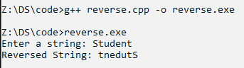

3.2. C++ Program to Reverse Each Word in a Sentence

ALGORITHM:
Step 1: Start the program.
Step 2: Declare string variables to store the sentence and individual words.
Step 3: Read the sentence from the user.
Step 4: Traverse the sentence character by character.
Step 5: Identify each word by checking for a space or the end of the sentence.
Step 6: Reverse each word using the reverse() function.
Step 7: Display each reversed word in the same sentence.
Step 8: Stop the program.

PROGRAM:
#include <iostream>
#include <string>
#include <algorithm>
using namespace std;
int main()
{
string str, word;
cout << "Enter a sentence: ";
getline(cin, str);
for (int i = 0; i <= str.length(); i++) {
if (i == str.length() || str[i] == ' ') {
reverse(word.begin(), word.end());
cout << word << " ";
word = "";
} else {
word += str[i];
}
}
return 0;
}
OUTPUT
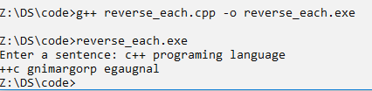

3.3. C++ Program to Evaluate a Postfix Expression

ALGORITHM:
Step 1: Start the program.
Step 2: Declare a string variable to store the postfix expression and create an integer stack.
Step 3: Read the postfix expression from the user.
Step 4: Traverse the postfix expression from left to right.
Step 5: If the character is an operand, convert it into an integer and push it onto the stack.
Step 6: If the character is an operator, pop the top two operands from the stack.
Step 7: Perform the corresponding arithmetic operation on the two operands.
Step 8: Push the result back onto the stack.
Step 9: Repeat the process until all characters in the postfix expression are processed.
Step 10: Pop and display the final result from the stack.
Step 11: Stop the program.

PROGRAM:
#include <iostream>
#include <stack>
#include <string>
using namespace std;
int main() {
string exp;
cout << "Enter postfix expression: ";
cin >> exp;
stack<int> s;
for (char ch : exp) {
if (isdigit(ch)) {
s.push(ch - '0');
}
else {
int val2 = s.top();
s.pop();
int val1 = s.top();
s.pop();
switch (ch) {
case '+':
s.push(val1 + val2);
break;
case '-':
s.push(val1 - val2);
break;
case '*':
s.push(val1 * val2);
break;
case '/':
s.push(val1 / val2);
break;
}
}
}
cout << "Result = " << s.top() << endl;
return 0;
}
OUTPUT
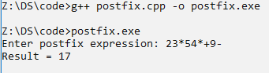

RESULT:
Thus, the C++ programs for reversing a string, reversing each word in a sentence, and evaluating a postfix expression using a stack were successfully implemented and executed. The required string manipulation and postfix evaluation operations were performed successfully.

